In Praise of the Middleman
The title of this blog says it all – this article focuses on praising the oft-maligned middleman. What isn’t yet discussed is why anyone should defend or even laud someone who is often considered by society at large as superfluous and, sometimes, even parasitic. To understand this controversial position, let’s first look at the conventional wisdom, take it apart a bit, and then see where the truth really lies.
The usual mode of thought surrounding the middleman is best summarized by the following diagram. Over on the left is the manufacturer of the goods or services sought by the consumer. On the right are the consumers needing or wanting the goods or services that the manufacturer provides. Stuck firmly in between is the middleman, from whose position derives his name. In other contexts, the manufacturer might be the subject of economic criticism for his ‘rapacious capitalistic ways that drive him to crush the worker and squeeze consumer’ or the consumer may come under question for conspicuous consumption and not being enlightened enough to understand the implications of his purchases, for failing to ‘think globally and act locally’. But the presence of the middleman distracts from all of that and he usually seems to draw all the criticism.
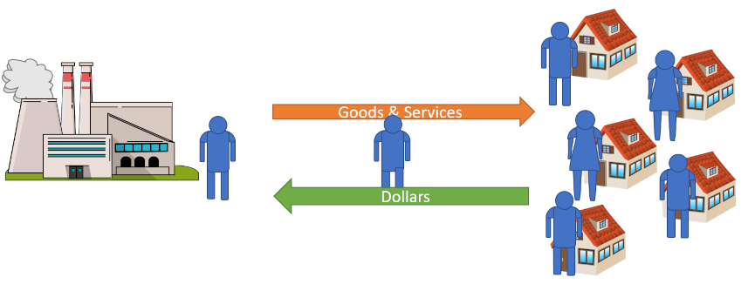
The reasons for this lack of status is well summarized in the article The Advantages of Eliminating the Middleman by Neil Kokemuller from April of 2018. In this article Kokemuller identifies four advantages but a critical reader who eliminates the overlap soon finds that there are only two distinct ones. First, by eliminating some of if not all the intermediary steps, the manufacturer can realize a greater profit while the consumer realizes a cost savings. Basically, the two ends of the process split the cost that would have been expended on the middleman and bank it for themselves. Second, because there are fewer steps, the process is both economically wiser and more environmentally friendly as there are fewer scarce resources used on securing the transaction between manufacturer and consumer. The time from source to destination is also faster leading to higher customer satisfaction and reduced time to settle on the producer’s side.
Kokemuller credits “Internet expansion” for this miracle release from the middleman, a sentiment more strongly (and perhaps humorously) expressed in the following excerpt from the written transcript of Steve Ely’s sermon The Middle Man:
< I despise the middle man! Don’t look at me like that you do too! We despise him because he causes the price to go up. So we look for deals straight from the factory. We will go to factory direct stores to bi-pass the middle-man. We want to save a few bucks so we order through the internet in an attempt to get around the middle-man.>
Despite the fact that even a man of God has railed against the middleman, is this common wisdom really wise. The answer is a qualified no. Sure, each of us can point to a salesperson in some store (usually of the department variety) who is incompetent and/or unmotivated, but do we really, roundly reject the concept of a middleman. Careful examination of our lives shows otherwise.
Consider first the ‘Internet expansion’, by which Kokemuller presumably means the fact that the internet facilitates a many-to-many relationship between consumers and producers that effectively by-passes the middleman. The reality is that the middleman is not only thriving but now controls a larger portion of the economic pie than before. Afterall, what are Amazon, Ebay, and Etsy if not middlemen enterprises designed specifically to connect consumers with manufacturers within a common framework.
In these cases, the primary benefit that these tech middlemen offer is convenience and trust. For example, within the Amazon marketplace ecosystem, a careful shopper can find the exact same goods offered by different sellers (middlemen of their own) at different prices. The structure Amazon provides makes payment to these individual institutions simple and convenient. So does the convenience of returns. The consumer need only interact with Amazon to purchase and return/exchange and the seller only need interact with Amazon to deliver and to collect. This middleman function is so effective that it has made Jeff Bezos, the owner of Amazon, one of the wealthiest people in the world.
Ebay works in similar fashion, and, like the Macy’s, Kaufman’s, and Gimbal’s of decades past (mostly remembered through The Miracle on 34th Street and the continued existence of Macy’s as a brand), offers slightly different product lines than Amazon but all still presenting themselves within a common ‘retail space’.
Curiously, Etsy seems to offer quite different product lines absent, for the most part, from the others, but, again, doing so within a common middleman framework wherein the consumer’s purchases from the producer are mediated through a common framework.
Other examples of middlemen on the internet abound. Hotels.com provides a middleman service between the traveler and their lodging-provider. Meta-middlemen like trivago (trivago even labels itself as a metasearch technology) or Kayak offer the middleman service of comparing individual middlemen side-by-side – for example, Hotels.com against its competitors.
However, all is not rainbows and sunshine. Two things are lost, to varying degrees, with these cyber-middlemen services: traditional expertise and purchasing power. Trusted middlemen of the older days added value by being personally involved in the procurement process. They weren’t just a convenient connection point for bundling transactions between many manufacturers and many consumers but they actively had reputations they protected by filtering out poor manufacturers, who passed off counterfeit or shabby goods and services and, conceivably, also filtering out poor consumers who had no intention of paying. After all, virtue is not the sole province of any side of an economic transaction. Along the way, these ‘boutique’ middlemen also offered purchasing power where they could negotiate a better price with the manufacturer that could an individual consumer. The relative scarcity of these type of intermediaries is probably the single biggest casualty of the internet age but it is a scarcity likely largely of their own making – very few people want to see trust and expertise it seems.
And that is the real shame. Each of us would rather pay a little more for the peace-of-mind that comes when a trusted agent acts on our behalf in matters where we have little or no expertise. Doctors, mechanics, and construction contractors who follow this approach never lack for business and usually must turn opportunities away. Unfortunately, the internet has turned more of us into middlemen but hasn’t increased the quality of the services provided but simply amped up the convenience in which they are delivered. Perhaps the only way that brick-and-mortar stores will substantially make a roaring comeback is by selling trust on a customer-by-customer basis.

